Instructor: Dr. Jie Shen
Release date: April 12, 2021
Due date: April 21, 2021

Student Name: Demetrius Johnson
*Special note: see my lab uploads of the .CPP and .EXE files for ease of access and testing any of the programs for any question.

Table of Contents
Question 1 Tree 3
Source code (USED C++ COMPILER on Microsoft Windows 10) 3
Test data and expected results 10
Submission of Your Work: 12

Question 1 Tree
In this assignment, perform the following four coding tasks:
- Create a struct TreeNode
- Use this TreeNode to construct a binary search tree based on the following input queue:
F, A, B, M, C, Q

- Use Inorder Traversal to print out the content of this tree

You need to provide screenshots of your code and running result.

Source code (USED C++ COMPILER on Microsoft Windows 10)
**note: I also uploaded these two .cpp files to canvas so you can view them easier.
MAIN FILE:

// CIS-200-LAB_11 -DemetriusJohnson.cpp : This file contains the 'main' function. Program execution begins and ends there.
//

/*
//Author: Demetrius E Johnson
//Date: 15 April 2021
//Last Modification Date: 04-19-2021
//Purpose: Use a tree struct node to demonstrate the structure of a Binary Search Tree data type
*/

/*
Question 1:

Question 1 Tree
In this assignment, perform the following four coding tasks:
(1) Create a struct TreeNode
(2) Use this TreeNode to construct a binary search tree based on the following input queue:
F, A, B, M, C, Q

(3) Use Inorder Traversal to print out the content of this tree

You need to provide screenshots of your code and running result.

*/

#include <iostream>
#include "BinarySearchTree.cpp" //had to just use a cpp file since template classes require more than just the declaration (because of how the compiler works at compile time)
//#include<assert.h>
using namespace std;

//FUNCTION DECLARATIONS

//FUNCTION DECLARATIONS

int main()
{
cout << "--WELCOME: This program uses a tree struct node to demonstrate the implementation of a Binary Search Tree data type--\n--BY Demetrius Johnson--\n\n\n";

BST<char> charBST;

cout << "Below is the In-Order print of a char Binary Search Tree:\n\n";
charBST.insert('F');
charBST.insert('A');
charBST.insert('B');
charBST.insert('M');
charBST.insert('C');
charBST.insert('Q');
//charBST.remove('B'); //used for testing; function works but it is defective because then destructor will no longer work

charBST.print_InOrder();

//did some additional testing below with a different data type to see if my program would hold up!

BST<int> intBST;

cout << "\n\n\n\nBelow is the In-Order print of an int Binary Search Tree:\n\n";
intBST.insert(1);
intBST.insert(4);
intBST.insert(-4);
intBST.insert(10);
intBST.insert(33);
intBST.insert(7);

intBST.print_InOrder();

cout << endl << endl << "\n\n\nThe program has finished execution....now exiting...thank you....\n\n";
system("pause");

return 0;
}

~END MAIN FILE
BST IMPLEMENTATION FILE:

/*
//Author: Demetrius E Johnson
//Date: 15 April 2021
//Last Modification Date: 04-19-2021
//Purpose: Use a tree struct node to demonstrate the structure of a Binary Search Tree data type
*/

//#include <vector>
#include<iostream>
//TREE NODE STRUCT:
template<class ItemType>
struct TreeNode
{

ItemType info; //hold the actual data information for the current node
TreeNode<ItemType>* left; //left child pointer
TreeNode<ItemType>* right; //right child pointer
//bool markedForDeletion = false; //use this to assist with the destructor function
};

//BINARY SEARCH TREE CLASS:
template<class ItemType>
class BST
{

private:
int length;
TreeNode<ItemType>* tempPtr; //use this to point to different parts of the tree; this will serve to help with writing insert and delete functions
TreeNode<ItemType>* root; //use this to store the address of the first element (which is also the root) of the tree structure
//std::vector<TreeNode<ItemType>*> nodeVector; //use this to store all addresses to assist with the destructor function

public:
BST() {

tempPtr = nullptr;
root = nullptr;
length = 0;

} //default constructor

bool binarySearch(ItemType searchItem) {

if (length == 0) { return false; } //execute this if length is 0; no nodes to search

tempPtr = root; //start search at the root node

while (true) { //execute this loop as many times as needed until return false or true occurs within the loop for if item is found or not

if (searchItem == tempPtr->info) { return true; } //item found; return true
else if (searchItem > tempPtr->info && tempPtr->right != nullptr) { //binary search using advantages of a BST structure: move to right child if greater

tempPtr = tempPtr->right;
}
else if (searchItem < tempPtr->info && tempPtr->left != nullptr) {//binary search using advantages of a BST structure: move to left child if smaller

tempPtr = tempPtr->left;
}
else { return false; } //item not found; there are no other nodes to search
}
}

void insert(ItemType addItem) {

bool isItemInTree;
isItemInTree = binarySearch(addItem);
if (isItemInTree == true) { return; } //item already in tree, no need to execute insertion alogrithm
if (length == 0) { //execute this if length is 0, which mean root node is null

root = new TreeNode<ItemType>; //allocate memory for the first node which is also the root to store the first element of the tree
root->info = addItem; //store the item in the new node
root->right = nullptr; //set right and left pointers to null since the new node has no children
root->left = nullptr;
length++;
return;
}

tempPtr = root; //set temp pointer to root so that we start at first element during the below while loop

while (true) { //this loop continues indefintely until the item is inserted, which should happen under all circumstances

if (addItem > tempPtr->info && tempPtr->right == nullptr) { //use this when we have finally reached a null child node
//and thus now it is time to allocate memory and add the item

tempPtr->right = new TreeNode<ItemType>; //allocate memory for new node to store the info
tempPtr = tempPtr->right; //move to the new node
tempPtr->info = addItem; //store the item in the new node
tempPtr->right = nullptr; //set right and left pointers to null since the new node has no children
tempPtr->left = nullptr;
length++;
return;
//use this for when item needs to be added and is Larger
}
if (addItem < tempPtr->info && tempPtr->left == nullptr) { //use this when we have finally reached a null child node
//and thus now it is time to allocate memory and add the item

tempPtr->left = new TreeNode<ItemType>; //allocate memory for new node to store the info
tempPtr = tempPtr->left; //move to the new node
tempPtr->info = addItem; //store the item in the new node
tempPtr->right = nullptr; //set right and left pointers to null since the new node has no children
tempPtr->left = nullptr;
length++;
return;
//use this for when item needs to be added and is Smaller
}
else if (addItem > tempPtr->info) { //use this to compare item to current node and move to RIGHT node if it is larger

tempPtr = tempPtr->right;
}
else if (addItem < tempPtr->info) { //use this to compare item to current node and move to LEFT node if it is smaller

tempPtr = tempPtr->left;
}

}

} //insert function

//I wanted to challenge myself so I wrote the remove function to see if I could figure it out;
//it works but it negatively affects other functions such as the destructor; thus I don't test it/use it
void remove(ItemType removeItem){

bool isItemInTree;
isItemInTree = binarySearch(removeItem); //this also sets tempPtr = to the node where the item was found
if (length == 0 || isItemInTree == false) { return;} //execute this if length is 0 or if item is not in the tree for removal

if (tempPtr->right == nullptr && tempPtr->left == nullptr) { //simple case; no children; thus we can simply delete the node contaning the removal item

delete tempPtr;
length--;
return;
}

if (removeItem == root->info) { //execute this special case in the event that the ROOT is to be DELETED from the tree

if (tempPtr->left != nullptr) { //if the root node has a left child, point to that node

tempPtr = tempPtr->left; //point to left node

if (tempPtr->right == nullptr) { //execute this if the left root branch's right branch is empty; this means we can simply treat the left branch as the new root

tempPtr->right = root->right; //we can simply let the left root branch take on the right branch if the left branch has an empty right branch
delete root; //delete old root
root = tempPtr; //set new root
length--;
return; //item removed; exit function
}
//execute below to do a overwrite and delete removal algorithm
while (true) { //go to right most node while in the left root branch,
//which will be the largest node and the node closest to the size of the current root

tempPtr = tempPtr->right; //move to the next right node
if(tempPtr->right == nullptr){ //use this to check: if the next right node is null,
//then we have found the right-most (largest) value in the root's left branch

root->info = tempPtr->info; //overwrite the root node info, which is to be removed, and replace its value with the largest value in the left root branch
delete tempPtr; //delete old node which has been moved to the root
length--;
return;
}
}
}
else { //else if left branch is empty, simply set root = right branch and delete the old root

root = root->right;
delete tempPtr;
length--;
return;
}
}

//now execute the below if the root is not the item to be removed:

TreeNode<ItemType>* itemPtr = tempPtr; //use this helper ptr to store a the node where the item is to be removed

if (itemPtr->right == nullptr) { //execute if the right branch of the removal item node is null

itemPtr->info = tempPtr->left->info; //overwrite removal node with the next largest value: the left branch value
itemPtr->left = itemPtr->left->left; //set left ptr to skip over the item that was just used to overwrite the removed item
delete tempPtr->left; //delete the old left node
length--;
return;

}
while (true) { //go to right most node so we can use that larger value to overwrite the node to be removed

tempPtr = tempPtr->right; //move to the next right node
if (tempPtr->right == nullptr) { //use this to check: if the next right node is null, then we have found the right-most node

itemPtr->info = tempPtr->info; //overwrite the removal item node info, which is to be removed, and replace its value with the larger value in the right-most branch
delete tempPtr; //delete old node which has been moved to the where the removed item was overwrtten
length--;
return;
}
}

} //delete function

void print_InOrder(void) { print_InOrder(root); } //use this as the no-parameter call, which prints a tree using the root as the default tree

void print_InOrder(TreeNode<ItemType>* nodeToPrint) {

//use recursion

if (nodeToPrint != nullptr) { //base case: check to make sure current node is not null

if (nodeToPrint->left != nullptr) {

print_InOrder(nodeToPrint->left); //move to left most-node by always moving to left node of the current node
}

std::cout << nodeToPrint->info << " "; //now that we are at the left-most portion of a given tree or sub=tree, print current node;
//this statement must go here in order to correctly print as Inorder tree print

if (nodeToPrint->right != nullptr) { //when we reach this if statement, it means the left-most nodes were already taken care of and printed
//this is in accordance with in-order print alogrithm; now we can move to the right nodes and print if necessary

print_InOrder(nodeToPrint->right);

}

}
} //print items using in-order traversal

int num_Elements(void) { return length; } //print out the number of elements in the tree

~BST() {

recursiveDestructor(root); //need to take advantage of recursion so I will tell the destructor to call a recursive function I have written

} //destructor: need to deallocate all tree nodes

void recursiveDestructor(TreeNode<ItemType>* nodeToDelete) {

if (nodeToDelete != nullptr) { //use this first if to ensure BST is not an empty tree

if (nodeToDelete->right != nullptr) { //use this to check right branches of any nodes

recursiveDestructor(nodeToDelete->right);

}
if (nodeToDelete->left != nullptr) { //use this to check left branches of any nodes

recursiveDestructor(nodeToDelete->left);

}

delete nodeToDelete; //now we have finally either reached a leaf node, or deleted all nodes below the current node, thus we are ready to delete current node

}

}
};

~END OF BST IMPLEMENTATION FILE

Test data and expected results

Test Table:
Test # | Valid / Invalid Data | Description of test | Input Value | Expected Output | Actual Output | Test Pass / Fail
1 | valid | Test in-order print of a charBST | F A B M C Q | ABCFMQ | See screenshot | pass
2 | valid | Test in-order print an intBST | 1 -4 4 10 33 7 | -4 1 4 7 10 33 | See screenshot | pass

*Notes: I had some struggles with the destructor and in-order print functions but eventually figured out that I needed to use recursion. Just for practice, I also tried to right a remove function; it worked properly but it causes other functions not work properly, but it was good practice; I had difficulty with resetting the pointer from the actual tree to null after deleting it; I only set the temporary pointer to nullptr which has no effect on the other pointer that is actually in the root tree…Thus, it causes issues with my other functions. Overall, I can’t believe I was able to finish this lab, it was very challenging, but it works!! And I wrote it as a template BST class!
TEST 1: CHAR BST
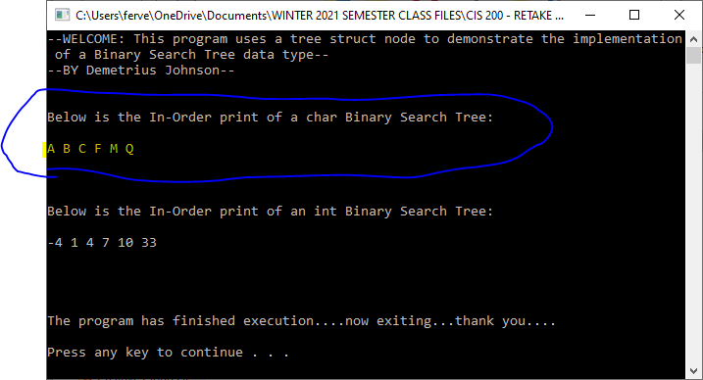
TEST 2: INT BST

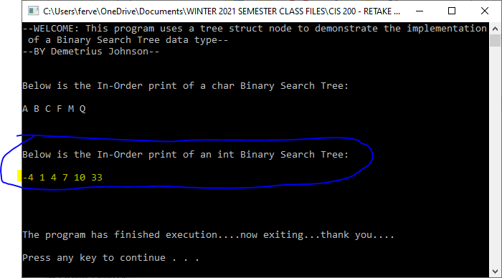

Submission of Your Work:

The Word document should contain the following information
- Your name
- Machine type (Unix, Mac, Linux or PC machine ?)
- Compiler type
- Description of your code design and implementation
- Inclusion of your source
- A reasonable number of comment lines in your source code
- Screen shot of your test run (required)

